Management review process |  |  |  |  |  |  |  |  |  | 
Document no |  |  | RS-MP-02 |  |  |  |  | Written by |  |  |  | Mark.Kim
Rev no |  |  | 001
Rev. date | 2022.10.17 |  |  |  |  |  |  | Department |  |  |  | QM
Revised contents |  |  |  |  |  | Drift |  |  | Review |  |  |  | Approval
 |  |  |  |  |  | / |  |  | / |  |  |  | /
Revised Items | AS IS |  |  |  |  | TO BE
Agreement | QM | R&D
 | Opinion:

[Revision history]
Revision history summary |  |  | RS-MP-02
 |  |  | Revision | 001
 |  |  | Confidential | G1
Rev. no | Rev. date | Simple description of changed contents | Author | Post
001 | 2022.10.04 | Newly established. | Mark.Kim | QM

1. Purpose and scope
This regulation is a process to monitor whether ramship's quality management system is maintained normally and to review whether the operation status of the quality management system is consistent with the quality management intention of the top management.

2. Apply scope
All of quality management system.

3. Definition of terms
3.1 Management review
Management review is a meeting that monitors whether our quality management system is maintained effectively and reviews whether the PDCA (Plan-Do-Check-Action) cycle of continuous improvement is maintained.
3.2 KPI (Key performance indicator)
It is an abbreviation of KPI (Key performance indicator) and means “performance indicator” of the core process.

4. Responsibility and authority
4.1 CEO
The CEO shall ensure the suitability and effectiveness of the company's quality management system as the chief manager and decision maker of ramship's quality management system.
4.2 CQO
The quality assurance office manager is responsible for maintaining and managing our quality assurance system, is responsible for monitoring various processes and KPIs, and may request improvement from the relevant department in case of systemic inconsistencies, and It has an obligation to report to the top management at all times.
4.3 Each department head
Each department head has an obligation to comply with the process applicable to each department.
Establish a plan for the achievement of each performance indicator, and establish a detailed action plan to achieve it to ensure that the process is effectively operated.

5. Process mapping
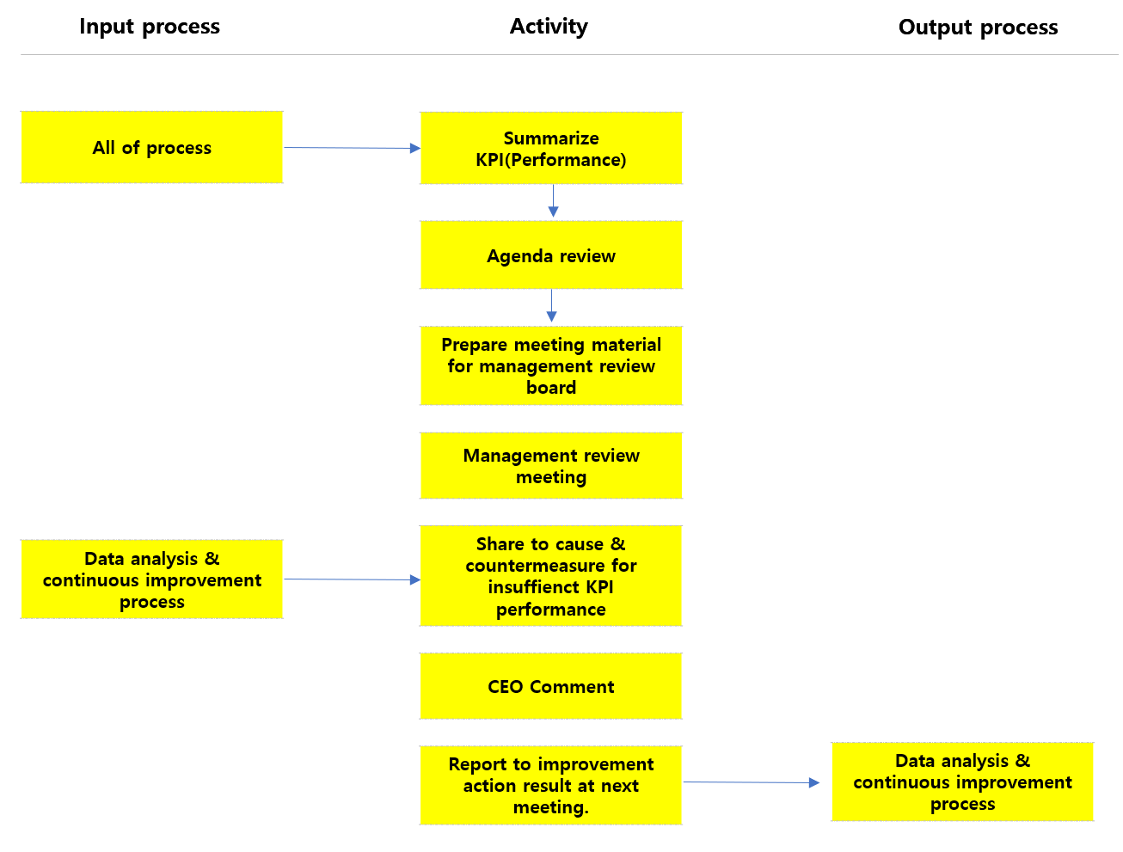

In  process | Input | Activity | Output | Out  process | Freq. | Review | Approval
All process | -. KPI performance | -. Each team prepare monthly performance report and, provide it to  Quality department. | -. KPI Summary | N/A | Occurred | Charged person | CQO
-. | -. KPI Summary | -. The QM department prepares the management review meeting after  Reviewing the prepared management review meeting materials. | -. Management review meeting materials | N/A | 1X/M | Charged person | CQO
- | -. Management review meeting materials | -. QM department announces the management review meeting schedule and releases the entire meeting data to CEO & relevant teams.  -. Each department present & report KPI performance, monthly issues, correctives actions, & improvement action plan to the CEO.  -. Based on the problems of each part and the corrective action plan, the CEO  orders corrective actions including the intention of the top management. | -. Meeting minute | N/A | 1X/M | CQO | CEO
- | -. Meeting minute | -. CEO’s instructions are recorded the biz meeting minutes and must be reviewed and tracked over the next meeting. | -. Meeting minute | -. Data analysis &  Continuous improvement process | Occurred  1x/Month | CQO | CEO

6. Document record & preservation
Material | Form code | Dept | Life
Meeting minutes | RS-FORM001 | QM | 5years

